29

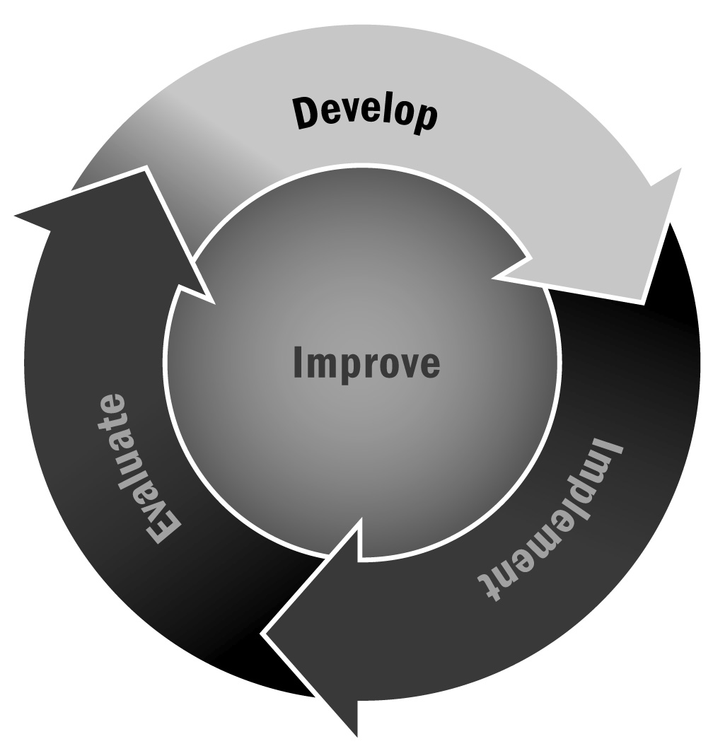
Community Communication Survey
In Chapter 1, you learned that understanding the preferences of the audience you are communicating with is a key component of effective communication. This tool can be used in conjunction with Tools 28 – 30 to support a comprehensive communication strategy for your program.
Directions: Use or adapt the survey on the following page to better understand the communication needs and preferences of community members.

Tips for Developing and Administering Surveys (For a Full List, See Tool 87)
- Consider your goals and expected outcomes for the survey. What are you trying to learn? Design a survey and develop questions that will help you achieve those goals and answer your ultimate question.
- Make sure you are familiar with the legal and institutional requirements, if any, when surveying families, community members, and especially youth.
- Prioritize your selection of survey questions.
- Consider your audience and make sure your survey will be understood easily.
- Write short questions that respondents can read quickly and easily.
- Make sure that each question has one central idea.
- Focus your questions on suggestions for improvement rather than focusing on negative experiences.
- Avoid leading questions that appear to advocate a particular answer.
- Provide instructions on how to record answers and how many options to select.
- For multiple choice questions, allow respondents to select “Other” so that they can provide a response that wasn’t included in the options.
- Test your survey with a small group before distributing it to all of your intended respondents.
- Think about how you will deliver the survey. Will it be delivered by mail, by telephone, in person, or online? These different methods will affect the survey design. It is likely that a paper survey will be the most convenient for respondents, but an electronic survey has advantages as well (such as allowing for skip logic and requiring less data entry) if it seems like a viable format for your respondents.
- Provide respondents with a contact person whom they can reach if they have any questions or concerns about the survey.

[Program Name] Community Communication Survey
Dear Neighbor:
[Program Name] offers programs for youth in [Location]. We want to keep you informed about our activities and about ways you can get involved. Please complete this brief questionnaire to let us know how we can best communicate with you about our program. All responses are anonymous.
If you have questions about the survey, please contact [Name] by phone (Phone Number) or email (Email).
- Please indicate which group(s) you belong to by checking the appropriate box(es).
(Check all that apply.)
❒ | School staff member | ❒ | District administrator
❒ | Program staff member or volunteer | ❒ | School board member
❒ | Family member of a school-age youth in public school | ❒ | Elected official (other than school board member)
❒ | Family member of a school-age youth in a  private or parochial school | ❒ | Faith community leader
❒ | Adult with no school-age youth | ❒ | Civic organization leader
❒ | Retired person | ❒ | Employer
❒ | School administrator | ❒ | Other (specify):

- What formats do you prefer for receiving general news and information about the program?
(Check your top three choices.)
❒ | Written newsletter | ❒ | Cable television
❒ | Online newsletter | ❒ | Newspaper
❒ | Email | ❒ | Public meeting
❒ | Radio | ❒ | Social media (e.g., Facebook, Twitter)
❒ | Television | ❒ | Other (specify):

- Where would you prefer to have public meetings concerning the program? (Check one.)
❒ | At the school |  | ❒ | At a centrally located site
❒ | Other (specify):

- What times are best for reaching you by telephone? (Check your top two choices.)
❒ | Weekdays, 6:00–8:00 a.m. | ❒ | Weekends
❒ | Weekdays, 8:00 a.m.–5:00 p.m. | ❒ | I am not easily accessible by telephone
❒ | Weekdays, 5:00–9:00 p.m.
Thank you for taking the time to complete this survey. Please return it to [Name] at [Address].

